Proposal

Safety-Silence Tradeoff Equation in Various Vehicle Traffic Conditions
Submitted by: George Corser

Proposal Title
Safety-Silence Tradeoff Equation in Various Vehicle Traffic Conditions

Proposal Abstract
In vehicular ad-hoc networks every 10 ms vehicles broadcast “heartbeat” messages, basic safety messages (BSMs) which include precise location coordinates. Vehicles use each other’s coordinates to avoid crashes, but eavesdroppers might use the same information for tracking or stalking. To confuse eavesdroppers, some privacy researchers recommend silent periods, spans of time during which vehicles cease transmissions. To what extent do silent periods impair safety? This research applies the Safety-Silence Tradeoff Equation, which estimates the probability of a crash given the proportion of vehicles transmitting BSMs in a region, to a range of vehicle traffic conditions.

Dates
January 1, 2015 to May 31, 2015

Funds Requested
$1000.00

Research Narrative
In vehicular ad-hoc networks (VANETs), wireless communications called Basic Safety Messages (BSMs) would be transmitted in order to help prevent collisions between vehicles. Accurate global positioning systems (GPS) installed in each vehicle would provide precise location data for BSMs. Each vehicle could compute future positions of its neighboring vehicles based on BSMs, and could alert drivers of impending collisions. BSMs would transmit precise locations unencrypted, which worries some location privacy researchers. Many recommend silent periods, spans of time during which vehicles occasionally cease transmissions to prevent wireless surveillance. The problem: what effect might silent periods have on safety?
Vehicular communications systems may one day save thousands of lives and billions of dollars, reduce fuel consumption and pollution, and advance ubiquitous connectivity and mobile application functionality. Such systems are designed to use and transmit both personal information and information which could be deanonymized to obtain personal information. Vehicle location data are of special concern because they could be used maliciously for stalking or other nefarious ends. This proposal advocates a systematic study to develop novel methods for providing location privacy specifically in vehicular settings.

1. Goals and Objectives
The expected contribution of this research is a formalization and quantification of the relationship between safety/security, network/application service quality/efficiency and availability, and privacy, i.e. anonymity of motorists. After simulating vehicle mobility under a variety of conditions it is hoped that a relationship will emerge, quantifying the tradeoffs.

2. Background and Context
One of the earliest and most cited papers [1] in the field of vehicular ad hoc network privacy included recommendations that privacy protection schemes include silent periods. This and other recommendations were founded on the results of seminal work in mix zones [2]. Silent periods and mix zones operate together. Vehicles cease transmitting and change positions, then begin transmitting again using different identifiers. Silent periods and mix zones have been proven to be effective, and some even suggest in cases where one mix zone is not enough, use multiple cascading mix zones for even more privacy protection [3].
Previous work in location privacy has not thoroughly considered vehicular mobility patterns. Previous work in vehicular network privacy has not solved the problem of collusion between MAC layer and application layer attackers. As defenses against location privacy attacks, previous work has favored the privacy methods of anonymization and obfuscation, but these methods have weaknesses. Spatial-temporal cloaking, for example, requires overhead of trusted third parties, and provides little protection in low vehicle densities especially when applications require frequent precise location data. Little published work has addressed the geographical distance of location privacy, focusing instead on the size of the anonymity set.

3. Significance and Impact
In order for policymakers to identify acceptable risks to the public they require reliable information regarding safety. For example, it may save one or two lives if governments were to put traffic lights on every corner, but the cost is prohibitive. So governments put traffic lights at those corners which save the most lives and are within the budget of the government.
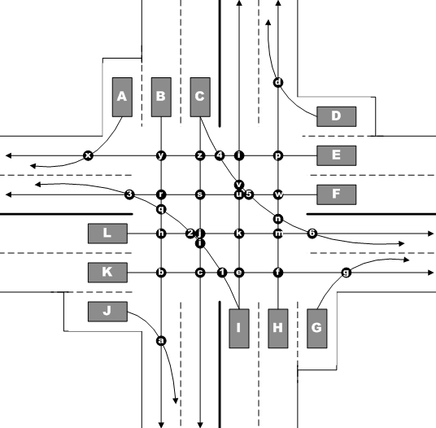
Likewise while privacy is a value to citizens, when vehicles turn of their BSM transmitters they expose a measurable risk of a crash. At the moment no one has quantified this risk. The purpose of this research is to contribute to the body of knowledge in this new research area.
The significance analogous to that of traffic engineering handbook information which identifies appropriate times to install traffic lights. The impact is intended to be an improved balance between location privacy protection and vehicle safety for drivers nationwide and worldwide.
Figure 1: Example Intersection

4. Timeline
While the overall work may take more time to compile, this project will be complete in one semester. The intent is to produce diagrams (See Fig. 1 for an example) of typical intersections and road segments, compute the number of possible vehicle interactions, then apply the Safety-Silence Tradeoff Equation to compute the safety-privacy relationship under those circumstances.

5. Evaluation
The ultimate evaluation is the acceptance of a paper by peer reviewers.

REFERENCES
[1] Sampigethaya, K., Huang, L., Li, M., Poovendran, R., Matsuura, K., & Sezaki, K. (2005). CARAVAN: Providing location privacy for VANET. WASHINGTON UNIV SEATTLE DEPT OF ELECTRICAL ENGINEERING.
[2] Beresford, A.R., Stajano, F.: Location privacy in pervasive computing. IEEE Pervasive Computing 2(1), 46–55 (2003).
[3] Beresford, A.R., Stajano, F.: Mix zones: user privacy in location-aware services. In: Pervasive Computing and Communications Workshops, pp. 127–131 (2004)

Budget

One student, $10 per hour, 100 hours.

Budget Milestones
10 intersection types, 10 hours per intersection

Contact

George Corser
gpcorser@svsu.edu
989.964.2756

